**Experiment 2.1**

**Logistic Regression**

**Student Name: Ishu Rattan UID:20BCS7755**

**Branch: CSE Section/Group:20BCS_MM_806-B**

**Semester: 5th**

**Subject Name: Machine Learning Lab Subject Code: CSP-317**

1. **Aim/Overview of the practical:**

Apply logistic regression on iris dataset**.**

1. **Source Code:**

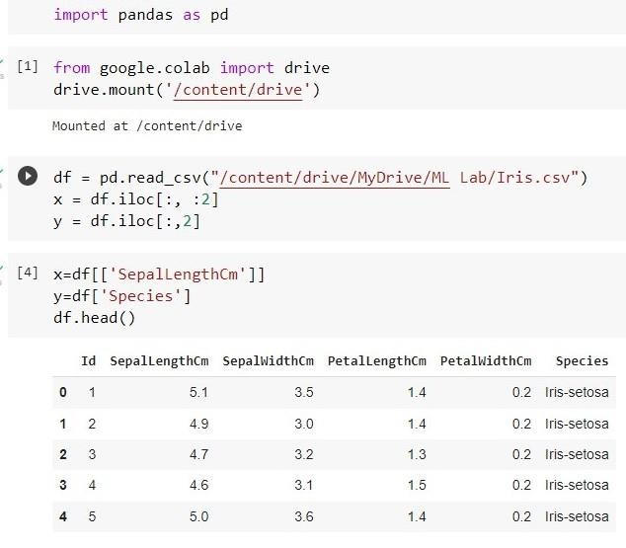

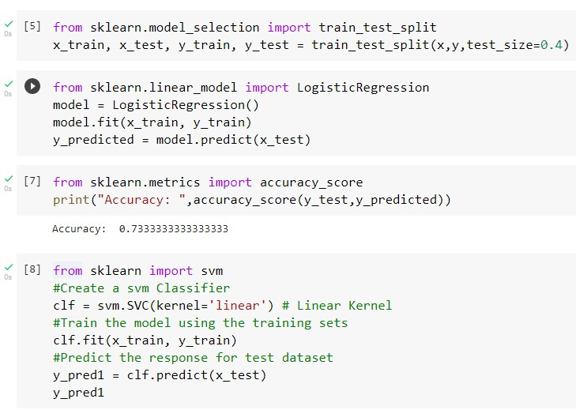

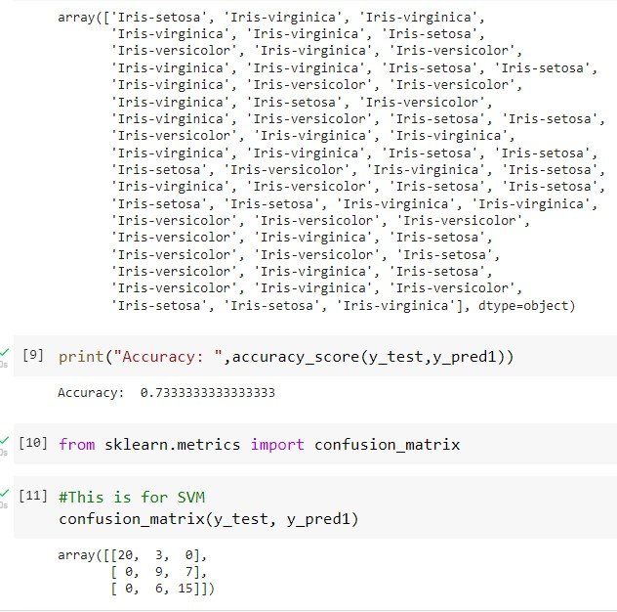

**Learning outcomes (What I have learnt):**

* 1. Learn about the Logistic regression algorithm
  2. Learn to perform the Logistic regression algorithm on iris dataset
  3. Learnt about the exploratory data analysis
  4. Learn to optimize the Model
  5. Got the clear concept of logistic regression classifier

**Evaluation Grid :**

|  |  |  |  |
| --- | --- | --- | --- |
| **Sr. No.** | **Parameters** | **Marks Obtained** | **Maximum Marks** |
| **1.** | **Student Performance (Conduct of experiment) objectives/Outcomes.** |  | **12** |
| **2.** | **Viva Voce** |  | **10** |
| **3.** | **Submission of Work Sheet (Record)** |  | **8** |
|  | **Total** |  | **30** |